**Predicting Cardiac Output from Arterial Blood Pressure**

**Part 1**

BME 580.431 Introduction to Computational Medicine I

Fall 2015

Drs. Raimond Winslow and Joseph Greenstein

Assigned Reading:

Sun et al (2009), The cardiac output from blood pressure algorithms trial. *Crit Care Med* 37(1): 72.

Sun et al (2005), Estimating cardiac output from arterial blood pressure waveforms: a critical evaluation using the MIMIC II database. *Comp Cardiol.* 32: 295.

Parlikar et al (2007), Model-based estimation of cardiac output and total peripheral resistance. *Comp Cardiol.* 34: 379.

**The Circulatory System: An Introduction**

The circulatory system forms a closed loop in which blood flows to carry oxygen from the lungs to the tissues throughout the body and to carry carbon dioxide back to the lungs (Fig. 1). The left side of the heart pumps oxygen-rich blood into the systemic arteries toward the capillaries. The now oxygen-depleted blood returns to the heart via the systemic veins and the right side of the heart pumps this blood into the pulmonary arteries to be distributed in the lungs. The oxygen-rich blood then returns to the left side of the heart via the pulmonary veins. Blood cells transit the full circuit in about one minute.

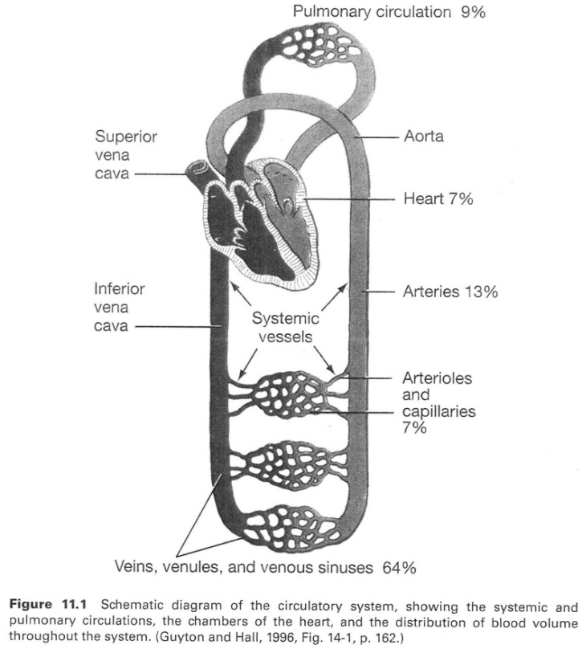

Blood pressure, *P*, is the force per unit area exerted on blood vessel walls, and varies both in time and distance along the circulatory system. A simple model of a blood vessel assumes it has a resistance, *R*, and that blood flow, *Q*, is linearly proportional to the pressure drop along the vessel such that *Q* = ∆*P*/*R*. This is the equivalent to Ohm’s law for an electrical circuit which relates current to voltage. In addition, blood vessels are elastic and will expand when blood pressure increases. The volume, *V*, of a vessel is linearly related the blood pressure such that *V* = *V*0 + *CP* where *C* is the compliance of the vessel and *V*0 is the volume of the vessel at zero pressure. This is the equivalent to the capacitor equation in an electrical circuit which relates voltage and charge.

One of the earliest models of the heart and circulation is known as the Windkessel model which was formulated by physiologist Otto Frank near the turn of the 19th century. The name derives from the German word for ‘bellows’. In a very simple version of this model we will consider the heart as a source of blood flow which passes through the arterial circulation modeled by a lumped single vessel. Figure 2 shows the equivalent electric circuit model in which a single resistor, *R*, represents the total peripheral resistance (TPR) and a single capacitor, *C*, represents the aggregate elastic properties of the systemic arteries.

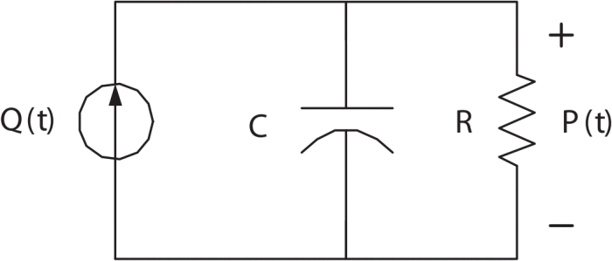

**Figure 2.** Windkessel model circuit representation (from Parlikar et al, 2007)

Using the equations for blood flow and vessel volume described above (assuming V0 = 0), the differential equation for the Winkessel model which relates aortic arterial blood pressure (ABP) as a function of time, *P*(*t*), to cardiac output (CO) (i.e. aortic blood flow), *Q*(*t*), can be derived as

$$C\frac{dP(t)}{dt}+\frac{P(t)}{R}=Q(t)$$

If we average this over the cardiac cycle, for the *n*th beat we obtain

$$C_{n}\frac{∆P_{n}}{T_{n}}+\frac{{\overline{P}}_{n}}{R_{n}}={\text{CO}}_{n}$$

where $T_{n}$ is the period, $∆P_{n}$ is the change in ABP, and ${\overline{P}}_{n}$ is the average ABP over the cycle (see Parlikar et al for details). In steady-state, the change in ABP is proportional to the change in volume of the circulation, which is equal to the volume of blood ejected from the heart, or stroke volume (SV). A number of estimators based on this simple model are designed to estimate SV and then CO can then be calculated when heart rate (HR) is known since CO = SV × HR.

Cardiac output is a very important parameter that clinicians use when assessing circulatory function and is normally in the range of 5 L/min. Unfortunately, CO cannot be measured directly in a noninvasive manner. Measurement of CO by thermodilution (TCO) involves the insertion of a catheter into the pulmonary artery and usually performed only on critically ill patients in the intensive care unit (ICU), and the procedure itself poses risk of complications. For this reason there is a great deal of interest in formulating noninvasive techniques for measuring CO.

The idea that changes in CO can be estimated from ABP has been around for a long time, and has attracted the attention of many investigators because peripheral ABP is routinely available in ICU patients. Several methods have been developed both in the academic literature and for commercial patient monitors. Despite these efforts, no single method has emerged as a leading candidate for use in the clinic. The study of Sun et al (2009) analyzed patient data from the MIMIC II database using a variety of these CO-from-ABP prediction algorithms in order to evaluate and compare their performance. The ICU physiologic data as well as the estimation algorithms (PhysioToolkit implemented in Matlab) used by these authors were made publicly available (http://www.physionet.org/physiotools/cardiac-output/). In this project, you will work with this data set and the authors’ own tools in order to reproduce their results and gain a greater appreciation for what steps are required to make sense of this “real-world” data.

**Estimating CO from ABP: Part 1**

1. Review the documentation for PhysioTookit software for Matlab found at http://physionet.org/physiotools/matlab/. This will give you some insight into the tools that are available for interacting with the MIMIC II datasets which are included within PhysioBank. This is just for informational purposes as the MIMIC II datasets needed for this project have already been extracted.
2. The data you will be using have been shared with you on OneDrive, a cloud computing resource available from your my.jh.edu portal. If you have not yet received an invitation to this shared drive, please see one of the instructors. This drive contains data for 282 MIMIC II patients. For each patient there is a numeric file (file names end with ‘n’) that contains a variety of vital signs measured once-per-minute (or less frequently). The first two rows of the file provide physiological variable name and units for each column. This file will contain one or more measurements of TCO for each patient. Please have a look at a few examples, and note that the files may not all contain the same set of variables, or list them in the same order for every patient. In addition, you will find files that contain time-series ABP data obtained a 125-Hz sampling rate (file names end with ‘ABP’). Column 1 is time in seconds and column 2 is ABP in mmHg. Note that there are no headers in these time-series files. Also note that there may be time periods for which data do not exist in these files. Familiarize yourself with the structure of these data.
3. The original Matlab files for the algorithms can be found at http://physionet.org/physiotools/matlab/code/. A copy of this folder has also been uploaded to the class repository on GitHub. For this project we will be working with Matlab codes in the ‘2analyze’ and ‘3estimate’ folders. The shared data on OneDrive contains MIMIC II patients for which there are both CO measurements and ABP signals recorded. As an example we will first work with patient ‘s00020’ (or #20). Read the description subtitled “ABP Signal Processing” of Sun et al (2009) in conjunction with the three Matlab functions in the ‘2analyze’ folder. Use these functions to reproduce traces similar to those shown in their Figure 1 (including the ABP waveform and features denoted by the symbols). Do this for patient #20, showing the first 20 ABP pulses starting at 10 hours, and repeat for the 20 pulses starting at 11 hours. Produce three more example traces taken from 3 additional patients. As a general rule, for this and all subsequent questions, plot and describe your results and prepare a documented version of your code that generates these results to be submitted.
4. All of the CO-from-ABP algorithms provide a relative estimate of CO which can be calibrated by one or more TCO measurements. We will use the calibration method called C2 in Sun et al (2009). Your task here is to reproduce the estimates of continuous CO as shown in their Figure 4. First do this for patient #20 (and for consistency, please plot results only over the first 12 hours for this patient), and then for an additional patient of your choice. For each of the two patients compare the Liljestrand algorithm (estimator #5) to two other algorithms of your choice. Note that the Matlab function estimate_CO.m in the folder ‘3estimate’ is not directly compatible, as provided by the authors, with the output of the ‘2analyze’ functions. A modified function estimateCO_v2.m has been provided in its place. This function requires, as output from the signal processing steps, a Matlab data file (.mat) with variables named: time, ABP, t_on, feat, and beatq. Please note that estimator #s 8, 9, and 11 cannot be used due to additional data requirements. Discuss the performance of your CO-from-ABP estimators (in a qualitative sense).
5. Here you will use Eureka to identify cohorts of patients for which CO will be estimated and compared. For example you may choose cohorts based on age, gender, diagnosis of cardiovascular disease vs. other disease types, etc. Each group should make comparisons between different kinds of cohorts. Eureka will identify MIMIC II patient identifiers that satisfy the cohort requirements. Not all of these patients will have had CO measurements. You will therefore need to cross-reference the cohort patients identified by Eureka to those that are in the OneDrive set. Aim to have at least ten patients from this study in each cohort. Repeat the analyses performed above to predict CO for each cohort and evaluate the performance of your estimators. Identify and discuss any significant differences in CO between your chosen cohorts.